**Abstract**

The digital world redefined the mode and manner of knowledge acquisition, being open to every human being. The internet extends a new world where everything is available; at any time, at anywhere. Thus, the importance of digital literacy is unavoidable as the wide network of google bestows upon us an uncontrollable world, apparently, doubly difficult to filter the most relevant information for our needs. Then enters the chatbot revolution in the Gen Z i.e., a generation of technologically competent adults, but not wanting to wait for long times to resolve their issues. So, MNC’s like Amazon, Zomato, Swiggy, etc. have been ahead of the curve in such aspects, but not the Indian Government. When the GST laws were implemented, aimed to usurp corruption right from the roots, naturally the number of people being blindly looted in the name of GST, like truckers, shopkeepers, etc was on the rise. This is the target demographic of our chatbot as we have personally faced this innumerable times. Keeping this in mind, our project aims to develop a new-found chatbot based on Natural language understanding that makes the process of searching easy, timesaving and eliminate the probability of irrelevant information.

**Methodology**

**Introduction:**

A chatbot is an application that can initiate and continue a conversation using auditory and/or textual methods as a human would do. A chatbot can be either a simple rule-based engine or an intelligent application leveraging Natural Language Understanding. Many organizations today have started using chatbots extensively. Chatbots are becoming famous as they are available 24*7, provide a consistent customer experience, can handle several customers at a time, are cost-effective and hence, results in a better overall customer experience.

**Uses**

* Customer support
* Frequently Asked Questions
* Addressing Grievances
* Appointment Booking
* Automation of routine tasks
* Address a query

**Prerequisites**

The prerequisites for developing and understanding a chatbot using Microsoft Azure are:

* Python 3.8.0 installed
* ujson
* tensorflow
* spacy
* pandas

**Introduction to RASA**

Rasa is an open-source machine learning framework for building [contextual AI assistants and chatbots](http://blog.rasa.com/level-3-contextual-assistants-beyond-answering-simple-questions/).

* 1. **RASA Architecture:**

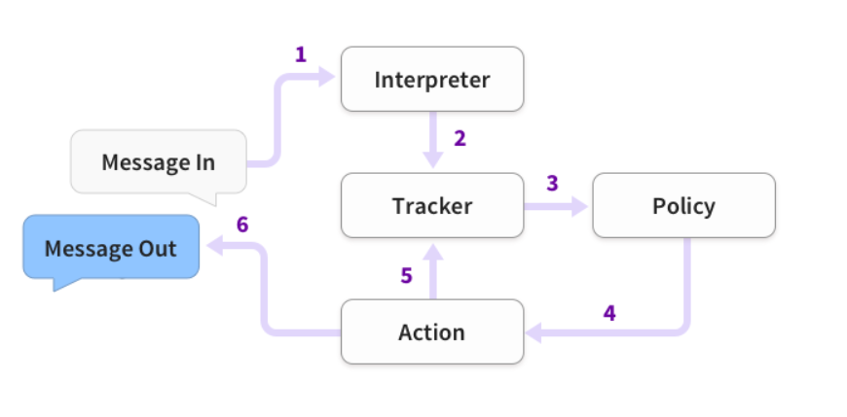

**The problem statements**

The goal here is to build a chatbot which can answer queries related to the GST.

**Technical stack:**

* + Python 3.8.0
  + ujson
  + Tensorflow
  + Rasa 2.1.2
  + Flask

**The application flows**

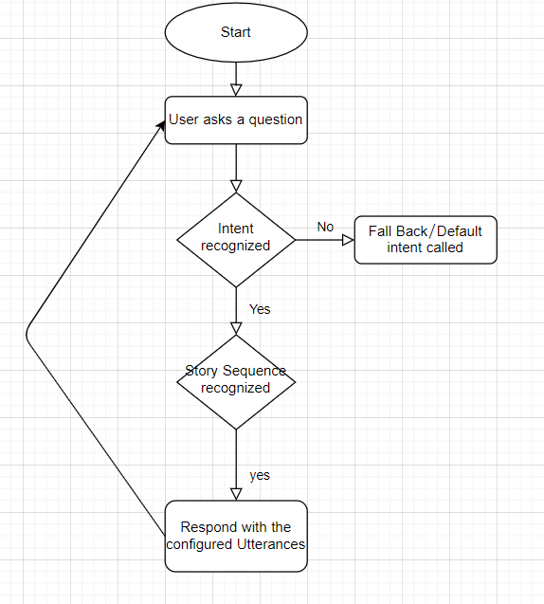

**Implementation:**

* Install Anaconda
* Create a virtual environment using Anaconda prompt
* Install ujson and tensorflow in Virtual Environment
* Install Rasa 2.1.2 in Virtual Environment
* Enter the command **rasa init** and for all the subsequent actions choose Y (for training the predefined model etc.).
* You’ll then end up with all the predefined structures which RASA would have built, as shown below:

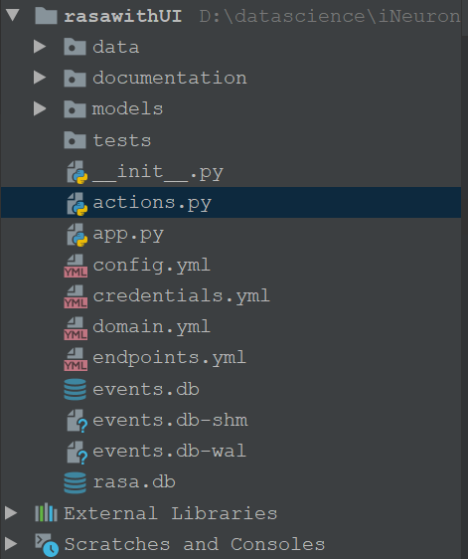

* Open the ‘nlu.md’ file from the data folder and enter the following content:

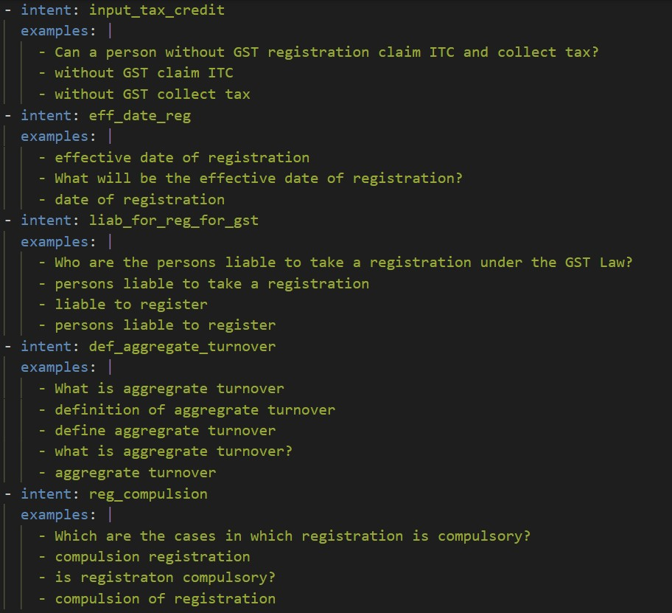

This file is used to create all the intents and their sample utterances for conversation.

Open the ‘domain.yml’ file and put the following content:

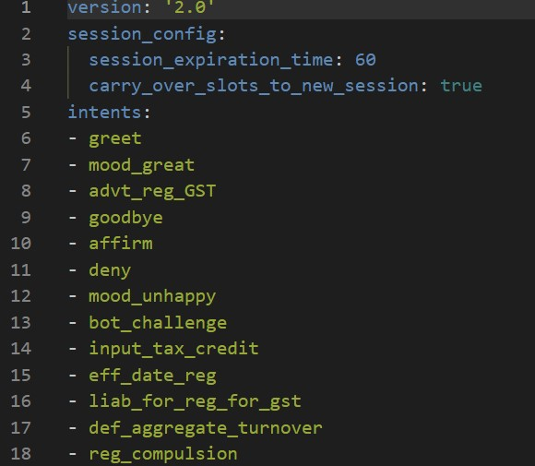

This file is used to configure the bot responses.

Open the ‘stories.md’ file from the data folder and put the following content:

This file is used to create the conversation flows.

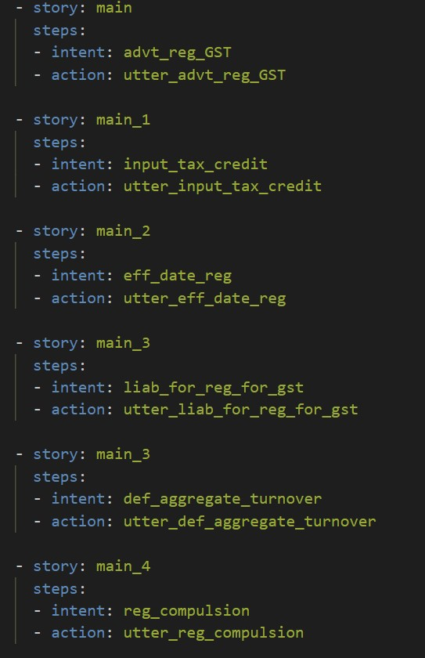

* We can train the bot with more custom intents and entities
* After all this, you can just enter the command ‘**rasa train’** to train the model with new conversation elements.



* Copy this URL in your web browser and you’ll see the web UI for your chatbot:

**Telegram Integration:**

* + Download ngrok from<https://ngrok.com/download>
  + After extracting the zip file, open the ngrok file and run it.
  + In ngrok, enter the command ‘**ngrok http 5005** ’:

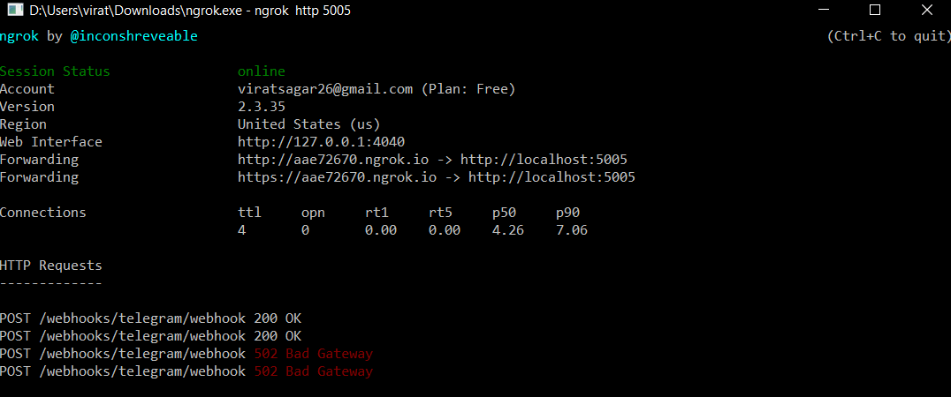

* Then go to telegram and create your own bot using botfather:

1. Open the telegram app and search for botfather (it is an inbuilt bot used to create other bots)
2. Start a conversation with botfather and enter /newbot to create a newbot.
3. Give a name to your bot
4. Give a username to your bot, which must end in _bot. This generates an access token.

* Open ‘credentials.yml’ and enter:

telegram:

access_token: "obtained from telegram"

verify: "your bot username"

webhook_url: "https://<ngrokurl>/webhooks/telegram/webhook"

* Go to terminal and enter the command ‘rasa run’
* Open one more terminal and run the command ‘rasa run actions’
* Now, you can chat with your bot from Telegram.
* 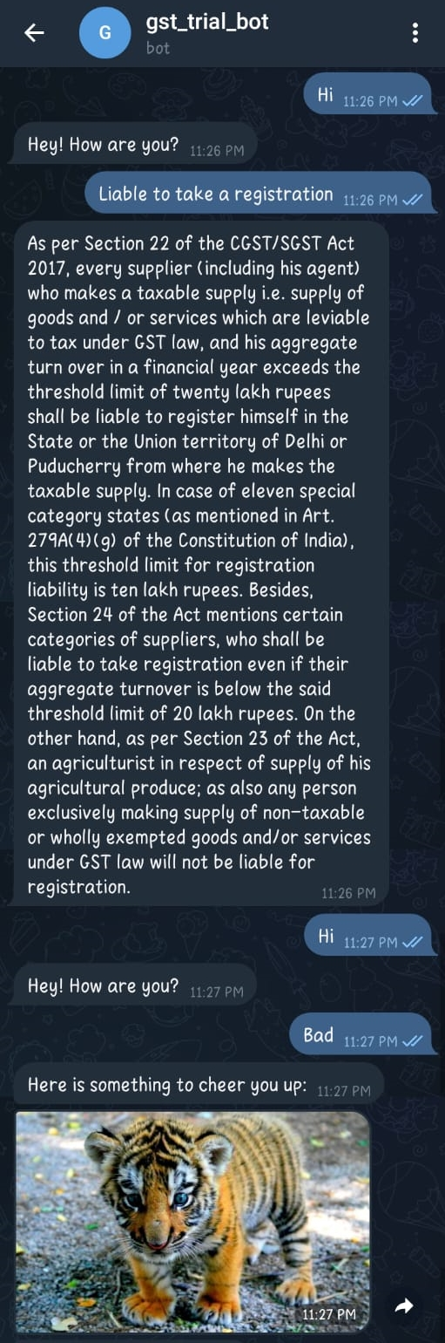

**GST chatbot UI using Flask API:**

